## CS425 Summer 2015

## Midterm Exam

## Closed Books and Notes

**Student Name: ________________________________**

**Section: ______________________________________**

**A# Last 4: _____________________________________**

Part 1 **Multiple Choices Answers. Please answer questions 1 – 32 in the table below**

|  |  |  |  |  |  |  |  |  |  |  |  |  |  |  |  |
| --- | --- | --- | --- | --- | --- | --- | --- | --- | --- | --- | --- | --- | --- | --- | --- |
| **1** | **2** | **3** | **4** | **5** | **6** | **7** | **8** | **9** | **10** | **11** | **12** | **13** | **14** | **15** | **16** |
|  |  |  |  |  |  |  |  |  |  |  |  |  |  |  |  |

|  |  |  |  |  |  |  |  |  |  |  |  |  |  |  |  |
| --- | --- | --- | --- | --- | --- | --- | --- | --- | --- | --- | --- | --- | --- | --- | --- |
| **17** |  |  |  |  |  |  |  |  |  |  |  |  |  |  |  |
|  |  |  |  |  |  |  |  |  |  |  |  |  |  |  |  |

**Student Grade: _________________________ / 70**

**Q1)** Which of the following is valid SQL for an Index?

A. CREATE INDEX ID; B. CHANGE INDEX ID; C. ADD INDEX ID; D. REMOVE INDEX ID;

**Q2)** The SQL keyword(s) ________ is used with wildcards.

A. LIKE only B. IN only C. NOT IN only D. IN and NOT IN

**Q3**) In an SQL SELECT statement querying a single table, according to the SQL-92 standard the asterisk   
 (*) (as in Select *) means that:

A. all columns of the table are to be returned.

B. all records meeting the full criteria are to be returned.

C. all records with even partial criteria met are to be returned.

D. None of the above is correct.

**Q4**) The HAVING clause does which of the following?

A. Acts like a WHERE clause but is used for groups rather than rows.

B. Acts like a WHERE clause but is used for rows rather than columns.

C. Acts like a WHERE clause but is used for columns rather than groups.

**Q4)** The SQL -92 wildcards are ____ and ____ .

A. asterisk (*); percent sign (%) B. percent sign (%); underscore (_)

C. underscore(_); question mark (?) D. question mark (?); asterisk (*)

**Q5)** To remove duplicate rows from the results of an SQL SELECT statement, the ________ qualifier specified must be included.

A. ONLY B. UNIQUE C. DISTINCT D. SINGLE

**Q6)** Find the SQL statement below that is equal to the following: SELECT NAME FROM CUSTOMER WHERE STATE = 'VA';

A. SELECT NAME IN CUSTOMER WHERE STATE IN ('VA');

B. SELECT NAME IN CUSTOMER WHERE STATE = 'VA';

C. SELECT NAME IN CUSTOMER WHERE STATE = 'V';

D. SELECT NAME FROM CUSTOMER WHERE STATE IN ('VA');

**Q7)** Which one of the following sorts rows in SQL?

A. SORT BY B. ALIGN BY C. ORDER BY D. GROUP BY

**Q8)** A SELECT statement within another SELECT statement and enclosed in square brackets ([...]) is called a subquery.

A. True B. False

**Q9)** A relation is considered a:

A. Column. B. one-dimensional table.

C. two-dimensional table. D. three-dimensional table.

**Q10)** What type of join is needed when you wish to include rows that do not have matching values?

A. Equi-join B. Natural join C. Outer join D. All of the above.

**Q11)** The following SQL is which type of join:

***SELECT*** *CUSTOMER_T. CUSTOMER_ID, ORDER_T. CUSTOMER_ID, NAME, ORDER_ID*

***FROM*** *CUSTOMER_T,ORDER_T*

***WHERE*** *CUSTOMER_T. CUSTOMER_ID = ORDER_T. CUSTOMER_ID*

A. Equi-join B. Natural join C. Outer join D. Cartesian join

**Q12- 20 Points)** All five questions involve a database about student organizations, with two tables:

**Clubs** (name, office, phone) and **Events** (sponsor, title, date, location, length).

Answer questions _1 thru 5) below using the following database instance.

|  |  |
| --- | --- |
| **Clubs Table** | **Events Table** |
| |  |  |  | | --- | --- | --- | | **name** | **office** | **phone** | | soccer | SH 120 | 5-8772 | | bowling | NH 283 | 5-2313 | | FOOTBAL | EB 118 | 5-8116 | | chess | CH 442 | 5-1133 | | |  |  |  |  |  | | --- | --- | --- | --- | --- | | **sponsor** | **title** | **Date** | **location** | **length** | | chess | Speed chess | 2-May | SMSU 14 | 60 | | chess | Opening moves | 5-May | CH 442 | 45 | | FOOTBAL | Python intro | 9-May | SH 120 | 90 | | FOOTBAL | Resume prep | 4-Jun | EB 276 | 45 | |

**Question 12.1** (5 points): write a SQL command to list the Titles of events with the shortest length?

**Question 13.2** (5 points): Names of clubs whose office is not the location of any event

**Question 14.3** (5 points): Change the scheme of either of the tables to allow a natural join to produce results?

**Question 15.4** (5 points): select the phone number and the name of the club for all Clubs who sponsor exactly 2 events.

**Question 16.5** (5 points): what are the output rows of this SQL command?

**SELECT** C.name, C.office

**FROM** Clubs C

**WHERE** C.office = SOME (SELECT E.location FROM Events E WHERE E.sponsor <> C.Name)

**Q17- 18 Points)** write SQL statements for the queries 17.1 - :

For question number 1 use the following relations:

1. Relation **businesses**

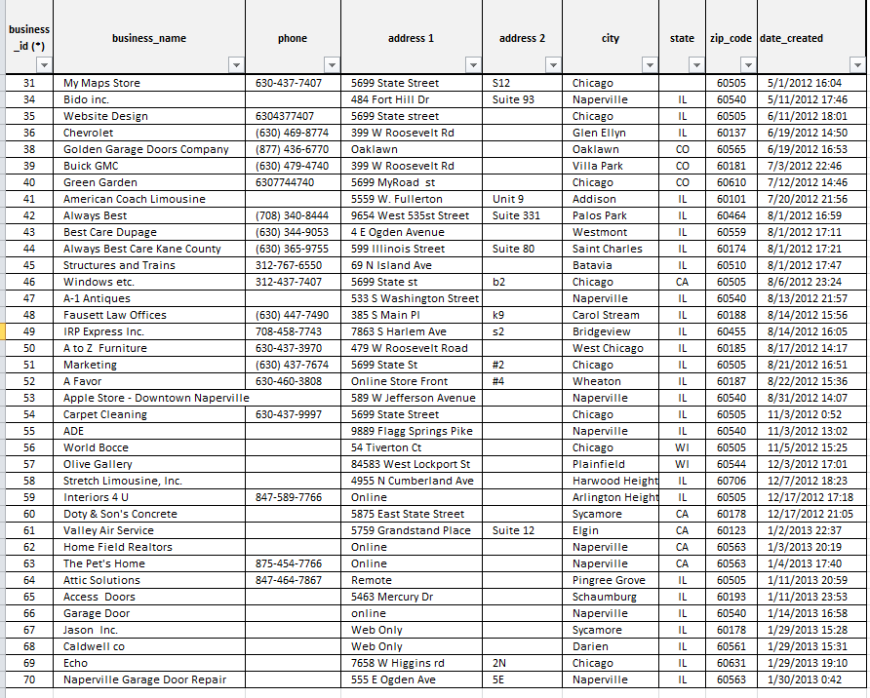

1. 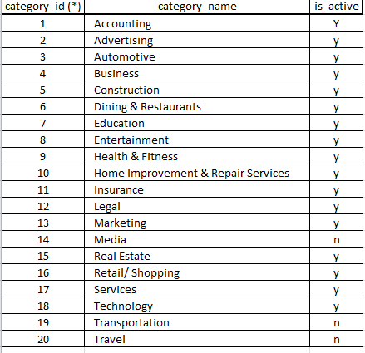Relation: **business_category** 3. Relation: **categories** 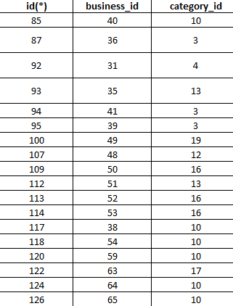

‘

**17.1**) list all business in California (CA)

**17.2**) list the name of the businesses from Naperville who were added on before Jan 1 2013

**17.3**) List businesses name and phone numbers for all businesses with phone number contains 630

**17.4**) list business id and name for all businesses missing phone number

**17.5**) list business id and name for all businesses in category 10

**17.6**) Select business names and ids for all businesses in Marketing category

**17.7**) list all businesses with category attached to them

**17.8**) List all businesses with a NOT active category (is_active = ‘n’)

**17.9**) find the number of tubles in relation businesses

**17.10**) find the number of businesses in each category

**17.11**) delete all records in categories table

**17.12**) join businesses and business categories